|  |  |
| --- | --- |
|  | **FPT ACADEMY INTERNATIONAL**  **FPT – APTECH COMPUTER EDUCATION** |

**Centre Name: ACE-HCMC-2-FPT.**

**Address: 590 Cach Mang Thang 8, District 3, Ho Chi Minh City, Viet Nam.**

**INSTITUTE OF FINE ARTS**

|  |  |  |
| --- | --- | --- |
| **Supervisor:** |  | |
| **Semester:** | 3 | |
| **Batch No:** | T11707E0 | |
| **Group No:** |  | |
| **Order:** | **Full name** | **Roll No.** |
| 1. | Le Cong Dat | Student1022144 |
| 2. | Tran Thi Tuyet Duyen | Student1030933 |
| 3. | Tran Tan Duy | Student1053750 |

October 2018

**This is to certify that**

**Mr./Ms.:**

Le Cong Dat

Tran Thi Tuyet Duyen

Tran Tan Duy

**has successfully designed & developed**

eProject: instituteoffineart.com Website

**Submitted by:**

Le Cong Dat

**Date of issue:**

10-Oct-2018

**Authorised Signature:**

**Acknowledgement**

This project consumed huge amount of work and dedication. Still, implementation would not have been possible if we did not have a support of many individuals. Therefore we would like to extend our sincere gratitude to all of them.

First of all we are thankful to Mr. Dinh Vu Quoc Trung for providing necessary guidance concerning projects implementation as well as her provision of expertise. Without her superior knowledge and experience, the Project could not have been successful. We also would like to express our sincere thanks towards the members of the team who devoted their time and knowledge in the implementation of this project.

Finally, we express our gratitude toward our families and colleagues for their kind co-operation and encouragement which help us in completion of this project.

**Synopsis**

Our client is an institute by the name “Institute of Fine Arts”, which has been started by the two well-trained professionals who are one of the standard people in the field of animation and fine arts. The procedures that they follow are they first conduct classes on paintings, animation, etc.

We offer users a clean and visual interface which help enhance user experiences and save time when they need to find information among the competitions of fine art in the University

In this website they want to implement these competitions, where in they can announce the competitions, provide a facility for the students to upload and download the image files. Also the student can update or remove the pictures of the same. Thus through this website they can automate the process, and as well reduce the time consumption in evaluating and fetching the records of the students, designs, etc. So they had approached you to help them by building a website by building the following functionalities, in it.

**PROBLEM STATEMENT**

After several enthusiastic discussions, our team have put ourself into student, staff, and manament’s position to find out problems and solutions in order to decrease time for making decision of customer base on detail information and showcase of products. We have to consider a series of question:

1. What is the most important thing that institute and … need?
2. How can we arrange information on a page?
3. How can the users interact with page?
4. How to hold the details of student, staff, competitions, awards, postings, exhibition details, details of the awards issued, postings send to the exhibition along with the status, etc .

The website is to be developed for the Windows Platform using HTML5, JavaScript and Geolocation. The site should work well in all leading browsers including Chrome, IE, Firefox etc.

**Analysis**

* User: public visitors, students, staffs (manager, administrator and the staff (lecturers) of the institute)
* Hold the details of student, staff, competitions, awards, postings, exhibition details, details of the awards issued, postings send to the exhibition along with the status, etc .
* Design an interface, through which the following are to be implemented such as Students can upload or edit or delete and search and retrieve the paintings that are posted based on the eligibility, Staffs can view the postings posted along with the details, and mark it as the best or better, etc. and provide the remarks.
* The reports are generated like the submissions received over a particular period for a particular competition that are best, etc.

**CUSTOMER'S REQUIREMENTS SPECIFICATIONS**

***Company****:* Institute of Fine Arts

***Website types:***Education *and* E-commerce Websites

***Website's specific functionalities:***

* Introduce the information and activities of institute.
* Manage details of staff and students
* Organize online paintings competitions and exhibitions for auction

**User Interfaces**

* The user interface for the website shall be compatible to any browser such as Internet Explorer, Mozilla, Google Chrome by which user can access to the system.

**Hardware**

* A minimum computer system that will help you access all the tools in the courses is a Intel core i3 or better
* 2 gigabytes of RAM or better

**Software**

* Notepad/HTML editor
* Dreamweaver
* IE v11, Google Chrome v61, Firefox v56
* Visual Studio 2017

**Scope of the work (in brief):**

After having time working together, we come into decision which need to be build:

1. Each entity is managed by website through six basic functions: view, insert, update, delete, search and report.
2. Each user has different role on accessing and managing data.
3. Homepage will show menu options for Home, Log in, About us, Exhibitions, Competitions, Contact us.

**Diagram of the website: ?? Home, categories**

Exhibition

Log in

About us

Contact us

Competition

Home

**TASK SHEET REVIEW 1**

|  |  |  |  |  |  |  |  |
| --- | --- | --- | --- | --- | --- | --- | --- |
| **Project Ref.No eP/Advertisement Portal Management System 01** | | **Project Title** | **Activity Plan Prepared By:** | **Date of Preparation of Activity Plans”** | | | |
| **No.** | **Task** | **Actual Start Date** | **Actual**  **Days** | **TeamMate Name** | **States** |
| 1 | Problem Statement | **Institute of Fine Arts** | All teammates | 10/10/2018 |  | All teammates |  |
| 2 | Analysis | All teammates |  |
| 3 | Customer’s requirements specifications | All teammates |  |
| 4 | Diagram of the website | All teammates |  |
| 6 | Task Sheet | All teammates |  |
| Dat |  |

|  |  |
| --- | --- |
| **Date:** | |
| Signature of Instructor:  **Mr. Dinh Vu Quoc Trung** | Signature of Team Leader:  **Le Cong Dat** |

**REVIEW II**

**Algorithms - Data Flowchart**

***Symbol generates:***

Decision

Process

Data

Start/End

Program flow

***Main data flow***

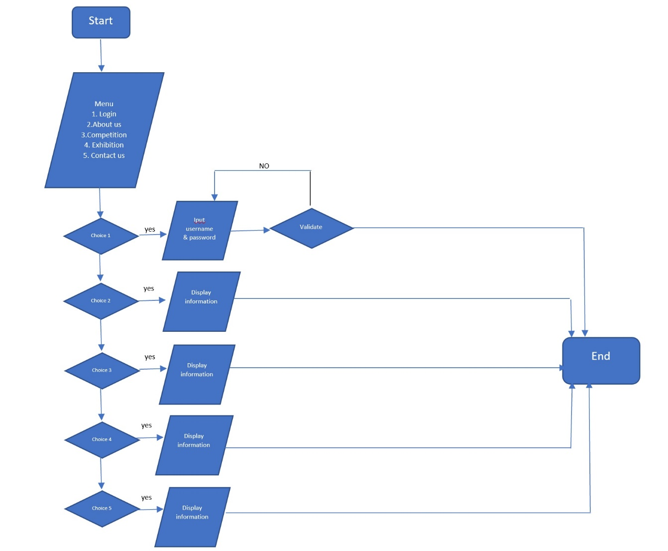

**Mock of the website:**

1. Administrator Manages Users

Administrator

User

1. Administrator Manages Manager

Administrator

Manager

1. Manager manages Exhibition

Manager

Exhibition

1. Staff manages Exhibition

Staff

Exhibition

1. Students manage Exhibition

Student

Exhibition

1. Administrator manages Exhibition

Administrator

Exhibition

1. Manager manages Competition

Manager

Competition

1. Staff manages Competition

Staff

Competition

1. Students manage Competition

Student

Competition

1. Administrator manages Competition

Administrator

Competition

1. Manager manages Students

Manager

Student

1. Staff manages Students

Staff

Student

1. Students manage Students

Student

Student

1. Administrator manages Students

Administrator

Student

1. Manager manages staff

Manager

Staff

1. Staff manages staff

Staff

Staff

1. Administrator manages staff

Administrator

Staff

1. Administrator Manages Exam

Administrator

Exam

1. Manager manages Exam

Manager

Exam

1. Staff manage Exam

Staff

Exam

1. Student Manages Exam

Student

Exam

**Entity Relationship**

n

n

n

Has

Student

Has

Staff

1

Has

n

n

1

n

n

n

Competition

Has

Exam

Has

Customer

n

Has

n

Exhibition

User Entity

|  |  |  |  |
| --- | --- | --- | --- |
| **User** | **Column Name** | **Data Type** | **Allow Null** |
| IDUser | nvarchar(10) | No |
| UserNick | nvarchar(20) | No |
| UserPass | nvarchar(20) | No |
| Real_ID | nvarchar(10) | Yes |
| Role | nvarchar(10) | No |
| SessionCode | nvarchar(50) | Yes |
| TimeExpire | datetime | Yes |

Student Entity

|  |  |  |  |
| --- | --- | --- | --- |
| **Student** | **Column Name** | **Data Type** | **Allow Null** |
| StudentID | nvarchar(10) | No |
| Name | nvarchar(50) | No |
| Gender | bit | No |
| DOB | date | Yes |
| Phone | nvarchar(11) | No |
| Address | nvarchar(50) | Yes |
| Class | nvarchar(50) | Yes |
| Admission | nvarchar(100) | Yes |

Staff Entity

|  |  |  |  |
| --- | --- | --- | --- |
| **Staff** | **Column Name** | **Data Type** | **Allow Null** |
| StaffID | nvarchar(10) | No |
| Name | nvarchar(50) | No |
| Gender | bit | No |
| DOB | date | Yes |
| Phone | nvarchar(11) | No |
| Address | nvarchar(50) | Yes |
| Class | nvarchar(50) | Yes |
| Subject | nvarchar(50) | Yes |

Exhibition Entity

|  |  |  |  |
| --- | --- | --- | --- |
| **Exhibition** | **Column Name** | **Data Type** | **Allow Null** |
| ExhibitionID | nvarchar(10) | No |
| Detail | nvarchar(200) | No |
| Country | nvarchar(50) | Yes |
| StartDate | datetime | No |
| EndDate | datetime | No |
| Condition | nvarchar(200) | Yes |
| Quantity | int | No |

Exam Entity

|  |  |  |  |
| --- | --- | --- | --- |
| **Exam** | **Column Name** | **Data Type** | **Allow Null** |
| ExamID | nvarchar(10) | No |
| Path | nvarchar(50) | No |
| Quotation | nvarchar(100) | Yes |
| Story | nvarchar(500) | Yes |
| IDStudent | nvarchar(10) | No |
| IDCompetition | nvarchar(10) | Yes |
| IDExhibition | nvarchar(10) | Yes |
| Mark | nvarchar(10) | Yes |
| IDAward | nvarchar(10) | Yes |
| ChangeDescription | nvarchar(100) | No |
| Status | bit | No |
| MoneyReturn | bit | Yes |
| Price | int | No |
| Improvement | bit | Yes |

Customer Entity

|  |  |  |  |
| --- | --- | --- | --- |
| **Customer** | **Column Name** | **Data Type** | **Allow Null** |
| CustomerID | nvarchar(10) | No |
| Name | nvarchar(50) | No |
| Gender | bit | No |
| Phone | nvarchar(11) | No |
| Address | nvarchar(50) | Yes |
| IDExhibition | nvarchar(10) | Yes |
| IDExam | nvarchar(10) | Yes |

Competition Entity

|  |  |  |  |
| --- | --- | --- | --- |
| **Competition** | **Column Name** | **Data Type** | **Allow Null** |
| CompetitionID | nvarchar(10) | No |
| Detail | nvarchar(200) | No |
| StartDate | datetime | No |
| EndDate | datetime | No |
| Condition | nvarchar(200) | Yes |
| Award | nvarchar(10) | Yes |

Comment Entity

|  |  |  |  |
| --- | --- | --- | --- |
| **Comment** | **Column Name** | **Data Type** | **Allow Null** |
| CommentID | nvarchar(10) | No |
| Detail | nvarchar(200) | Yes |
| UserID | nvarchar(10) | No |
| MainID | nvarchar(10) | No |

Award Entity

|  |  |  |  |
| --- | --- | --- | --- |
| **Award** | **Column Name** | **Data Type** | **Allow Null** |
| AwardID | nvarchar(10) | No |
| PriceLevied | int | No |
| CompetitionID | nvarchar(10) | Yes |
| Quantity | int | No |

**TASK SHEET REVIEW 2**

|  |  |  |  |  |  |  |  |
| --- | --- | --- | --- | --- | --- | --- | --- |
| **Project Ref.No eP/Advertisement Portal Management System 01** | | **Project Title** | **Activity Plan Prepared By:** | **Date of Preparation of Activity Plans”** | | | |
| **No.** | **Task** | **Actual Start Date** | **Actual**  **Days** | **TeamMate Name** | **States** |
| 1 | Mock of the website | **Institute of fine arts** | All teammates | 10/12/2018 |  | All teammates |  |
| 2 | Flow chart | All teammates |  |
| 3 | Task sheet | Dat |  |

|  |  |
| --- | --- |
| **Date:** | |
| Signature of Instructor:  **Mr. Dinh Vu Quoc Trung** | Signature of Team Leader:  **Mr Le Cong Dat** |